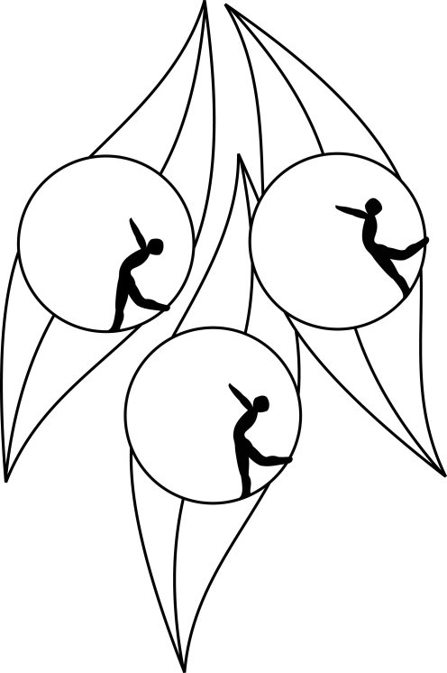
Results
South Australian Ice Skating Association Inc
Test Session

8 August 2010
IceArena, Thebarton

Congratulations to the following skaters:

Primary
India Nette

Elementary 1 Figure Pattern
Sakura Conlon

Elementary 1 Technical
Madeline Swan

Preliminary
Wenquing Zhao
Emily Dorosch

